**Software Testing Training Partner Smart Bridge**

**Trainer Name: Baranidharan**

**10.06.2024**

API (Application Programming Interface) – Payment Gateways

Ex: GPay API acts as an interface between user and other beneficiaries

**3 purposes**

* Web Application
* Mobile Application and
* API

Testing can be classified in to **1. Manual Testing 2. Automated Testing**

Min Salary Software Testing Rs. 40,000 Experts Salary - 50 Lakhs p.a

**Software Testing Tool: Katalon – 30 days trial**

**Unit 1: Introduction to Software Testing**

**Unit 2: Introduction to Katalon Studio**

**Unit 3: Test Case Creation and Management in Katalon Studio**

**Unit 4: Katalon Studio Best Practices and Tips**

**Unit V: Katalon Studio Reporting and Analysis**

Bug: Error Debug: Rectifying Errors

**CI : Continuous Integration**

**CD: Continuous Delivery**

**Git 101:** GIT full form is **Global Information Tracker**, and is a powerful and widely-used version control system commonly used for software development and other collaborative projects.

Inspect:

**Unit 1: Introduction to Software Testing (06 Hrs)**

**Intro to SW Testing: (Verification and Validation)**

**Software Testing: Verifying and validating the software**

**Quality Checking**

**Should satisfy customer requirements**

**The process of checking the quality,**

**Types of software Testing: https://www.geeksforgeeks.org/software-testing-basics/**

1. **Manual Testing: White Box, Black Box(Functional Testing and Non Functional Testing) and Grey Box**

**Functional Testing: Unit Testing, Integration Testing, System Testing**

1. **Non Functional Testing: Performance Testing, Usability Testing, Compatibility Testing**

**Performance Testing: Load Testing, Stress Testing, Scalability Testing, Stability Testing**

1. **Automation Testing**

**Test Automation Tools**

**Selenium -** Open source tool for automating web browsers **(web Application Testing)**

**Jenkis** - An open source tool for continuous integration and continuous delivery **(CI/CD Automaton)**

Appium **(Mobile Application Testing)**

Junit **(Unit Testing)**

Katalon Studio **(Web, API and Mobile Testing)**

SoapUI **(API Testing)**

Postman **(API Testing)**

**P F E I stands for – Pass Fail Execute Integrate**

**Unit 1:**

**Software Testing Life Cycle:**

* **Requirement Analysis**
* **Test Planning**
* **Test Case Development**
* **Environment SetUp**
* **Test Execution**
* **Test Cycle Closure**

**What is Software Testing:**

**Evaluate and verify that a software application or system meets the specified requirements and works as expected**

**Executing the software with the intent of finding defects, ensuring the software that is free of bugs and verifying that it functions correctly under various conditions**

**Objectives of software testing:**

* **Identifying defects**
* **Ensuring quality**
* **Validation & verification**
* **Preventing defects**
* **Ensuring reliability**
* **Ensuring security**

**Types of software testing:**

**Manual Testing: Testers manually execute test cases without using any automation tools. It involves human intervention to perform the testing process**

**Types of Manual Testing:**

**White Box Testing(unknown internal code structure): Application Testing that provides the tester with complete knowledge of the application being tested, including source code and design documents**

**Black Box Testing (known internal code structure): Specification based testing, is a method of software testing that examines the functionality of an application without peering into its internal structures or workings**

**Grey Box Testing(Internal code structure partially known): Combination of Black box and white box testing. It involves access to internal coding to design test cases as white box testing and testing practices are done at functionality level as black box testing.**

**Types of software testing:**

**Automated testing:**

**Testers use automated tools to execute test cases (projects). This helps in executing repetitive tasks efficiently and quickly.**

**Levels of Software Testing:**

**Unit Testing: Testing individual components or modules of the software to ensure they work correctly in isolation**

**Integration Testing: Testing the interaction between integrated components or systems to ensure they work together correctly**

**System Testing: Testing the complete and integrated software system to verify that it meets the specified requirements**

**Acceptance Testing: conducting tests to determine if the software meets the acceptance criteria and is ready for deployment. This is often performed by end users.**

**Functional and Non Functional Testing:**

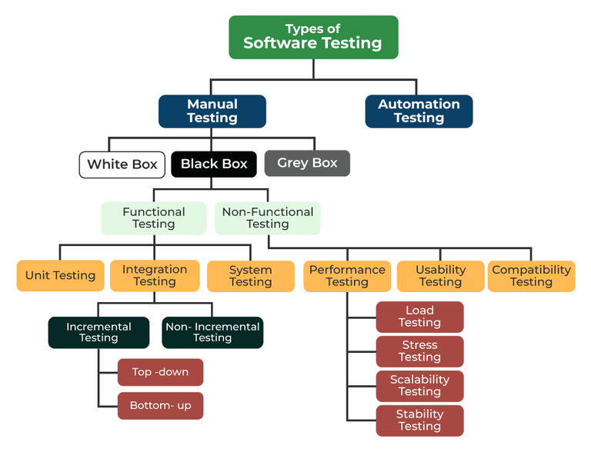

Structural Testing:

White Box Testing: Test the internal structures or workings of an application

Black Box testing: Tests the software without any knowledge of the internal workings

Focuses on input and output

Gray box tesing: hybrid

Benefits of software testing:

* Improves product quality
* Reduces development costs
* Ensures customer satisfaction
* Minimize risks

**Importance of software testing in software development:**

* Ensures software quality
* Identifies and fixes defects early
* Enhances user satisfaction
* Reduces risk
* Facilitates smooth deployment
* Improves performance
* Enhances maintainability
* Boosts development efficiency

**Fundamentals of software testing**

* Testing principles
* Levels of testing
* Types of testing
* Test design techniques
* Test management
* Test automation
* Metrics and measurement
* Testing tools and environments

**Fundamentals of test automation**

* Understanding test automation
* Benefits of test automation
* Key components
* Types of automated testing
* Best practices in test automation
* Challenges
* Metrics and measurement
* **Choosing the right tools (automation tool)**
* Integration with CD/CI

**What is test automation:**

Test automation involves using specialized software tools to control the execution of tests and compare **actual outcomes against predicted outcomes**

Automation testing is essential for enhancing the efficiency, accuracy and coverage of the software testing process

**Why Automate Tests?**

Manual testing can be time consuming, error-prone and repetitive

Efficiency, consistency, reusability, coverage, continuous testing

**Components of test automation:**

**Test automation framework:** Data – driven framework, keyword-driven framework, hybrid framework)

Automation Tools: Selenium, Junit/TestNG, Appium, Jenkins)

Test scripts: code written to automate test cases (java script)

Test Data: Data used for executing test cases

Test Environment: A controlled setting where tests are executed, including hardware, software and network configurations

**Advantages and disadvantages of test automation**

**Advantages:**

* Efficiency and speed
* Consistency and reliability
* Increased test coverage
* Cost savings over time
* Early defect detection
* Enhanced reporting and metrics

**Disadvantages:**

* High initial investment
* Maintenance overhead
* Tools limitation

**Automate:**

Repetitive tasks, large volume of tests, critical functionality, complex calculations, performance testing, frequent builds and deployments, environment consistency

**When not to automate**

Exploratory testing, short term projects, unstable features, usability testing, low risk areas

**11.06.2024 (Day 2)**

**Unit II - Introduction to Katalon Studio (04 Hrs)**

**Steps:**

1. **Create one gmail account**
2. **Goto Katalon Studio website (katalon.com)**
3. **Download Studio**
4. **Click the Download Studio Enterprise -> 30 Days free trial**
5. **After downloading install the setup.exe file**
6. **When you start installing it will take 5 to 10 minutes to finish the procedure**
7. **After completion of installation it will ask 3 options 1. Login from browser 2. License Server 3. Offline license**
8. **We can choose login from browser**
9. **Continue with google**
10. **Enter ur gamil id and password**
11. **Sometimes it will ask two step verification**
12. **Then continue**
13. **Select a project type to start your walkthrough with katalon studio(webUI, Mobile, Desktop (desktop Applications), BDD-Behaviour Driven development) – collaboration between developers, testers – Behavior of an application)**
14. **After selecting webAPI**

Katalon Studio : Create a new gmail account. Username: preetha.mrcas@edu.in

Google download katalon studio -> install katalon.exe connect with google username and password

Katalon once installed right click and click pin to taskbar

Three steps going to test with katalon Web, Mobile and API.

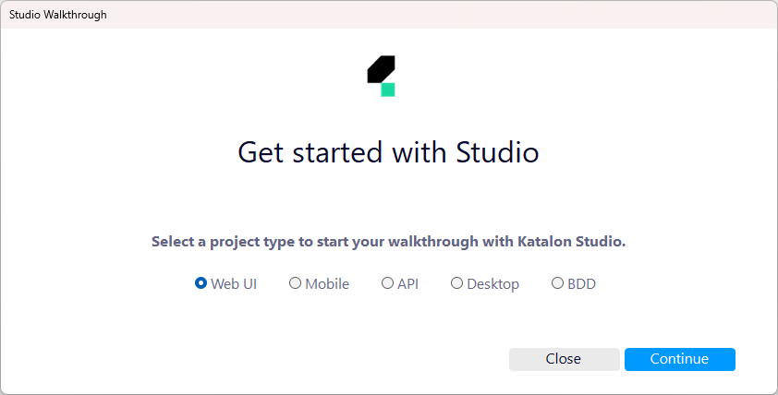

Choose web UI and click continue

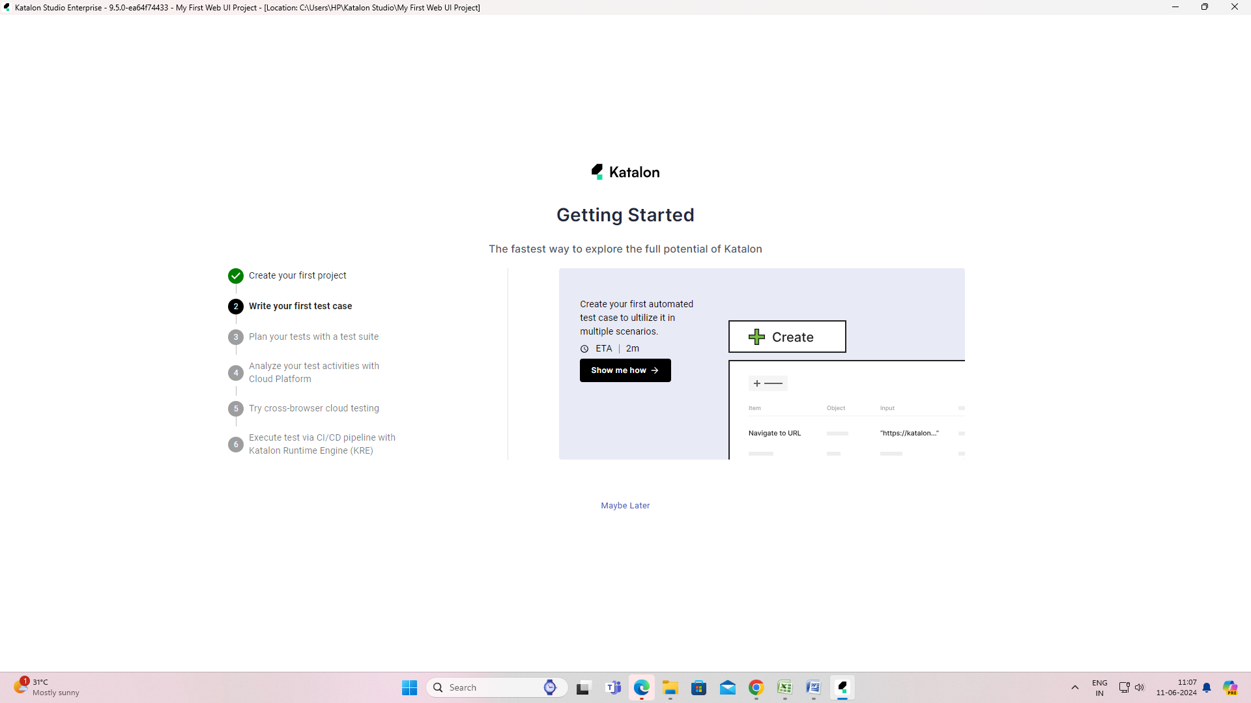

Click May be Later 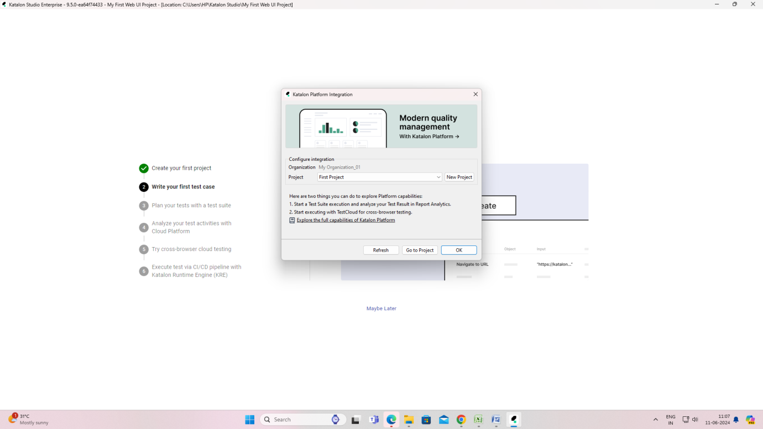

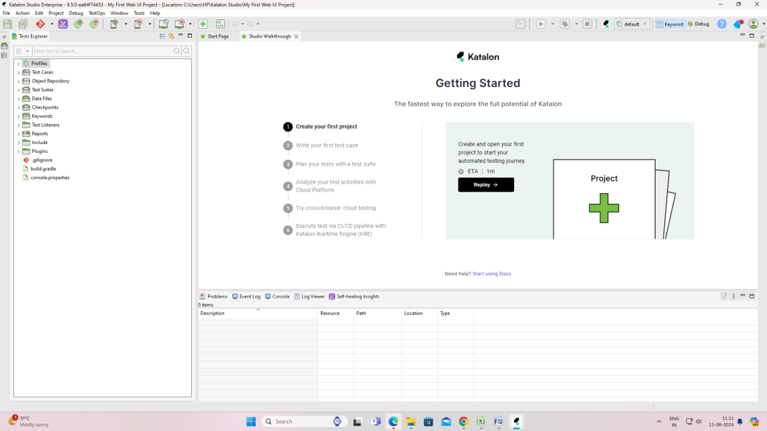

To create a New Project

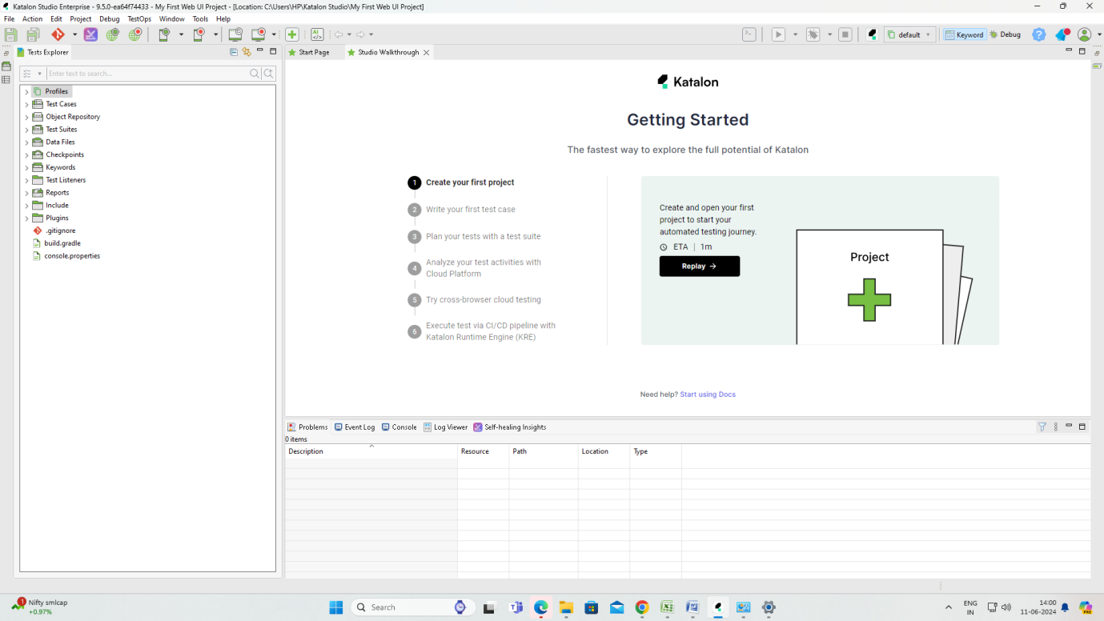

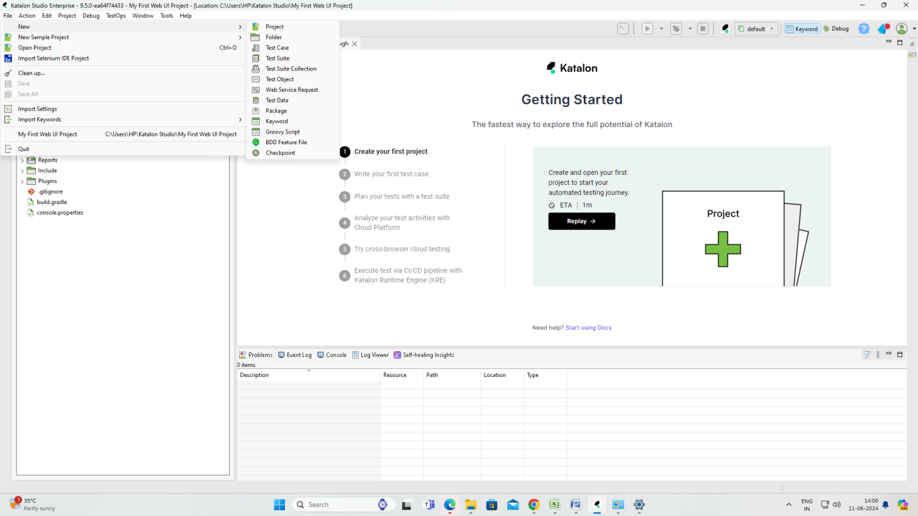

New Sample Project

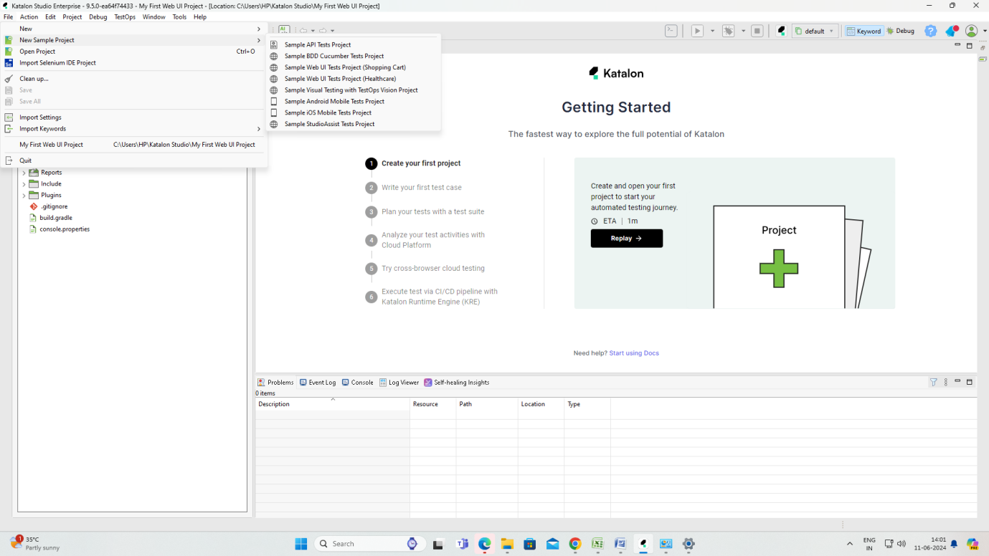

Tools – GIT, Recorder(web, mobile, windows actions), Create new test case

Dashboard - Profiles, Testcases

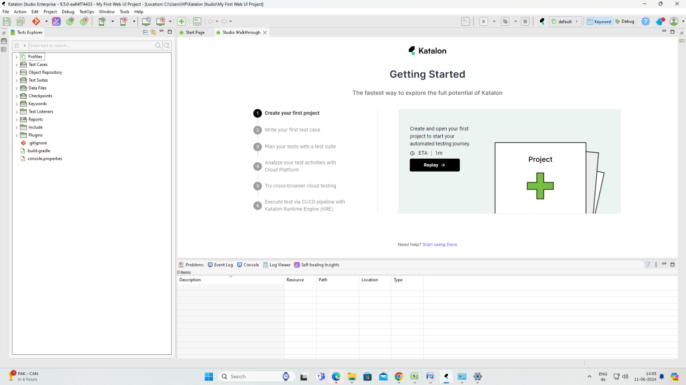

Create a New Project

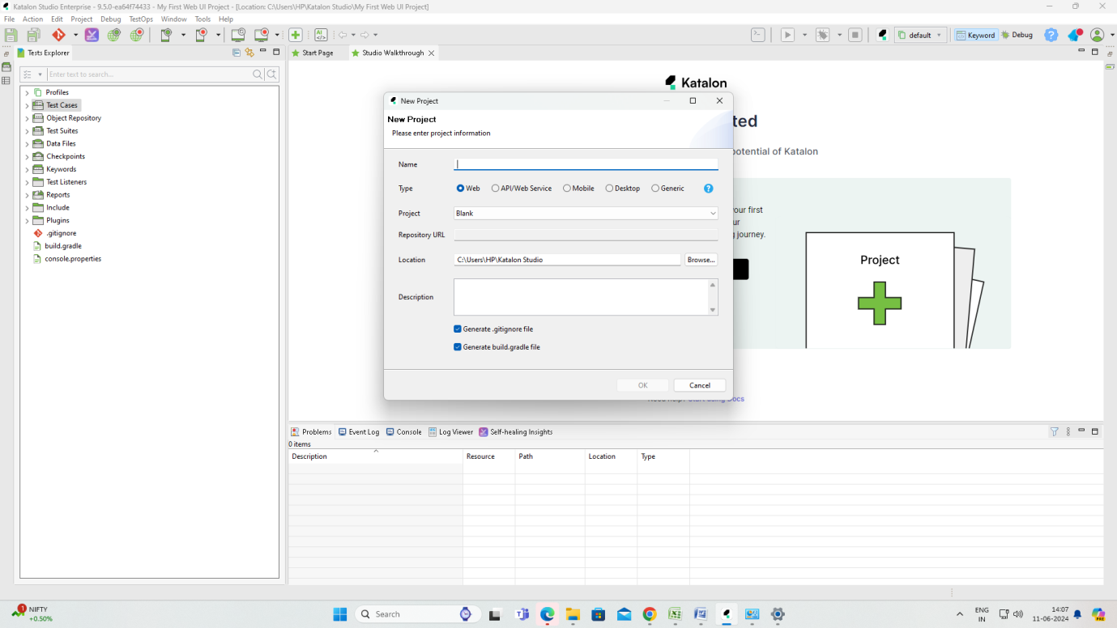

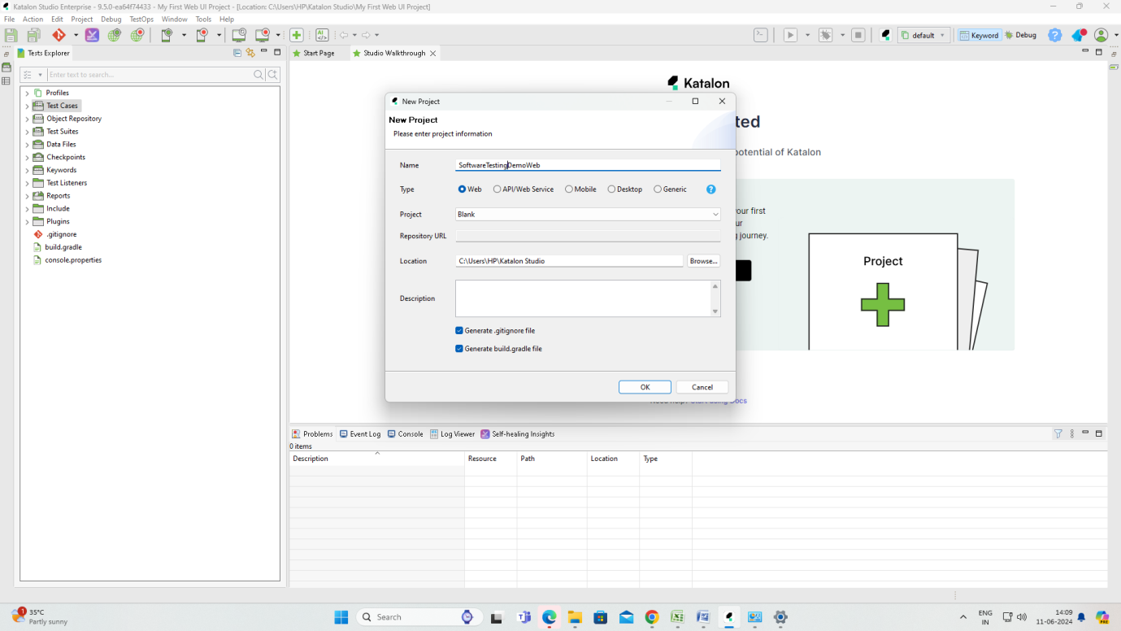

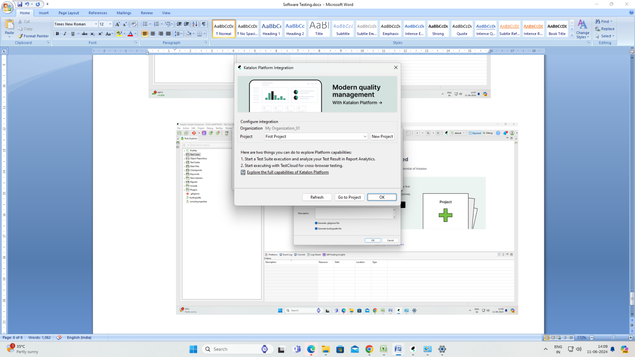

Project Title is created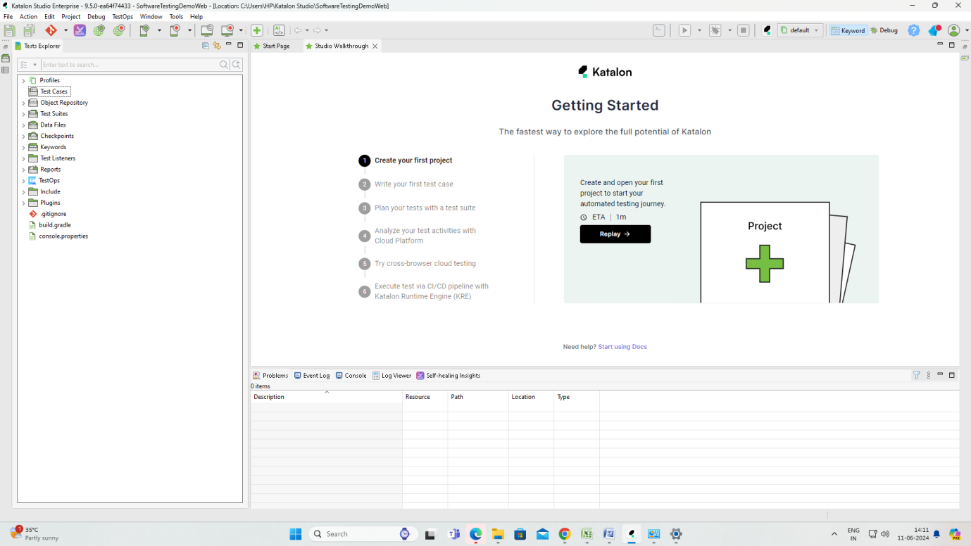

Test URL

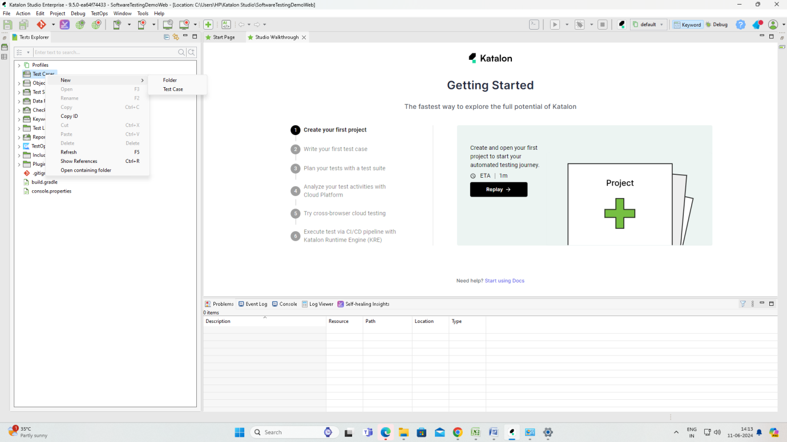

Folder

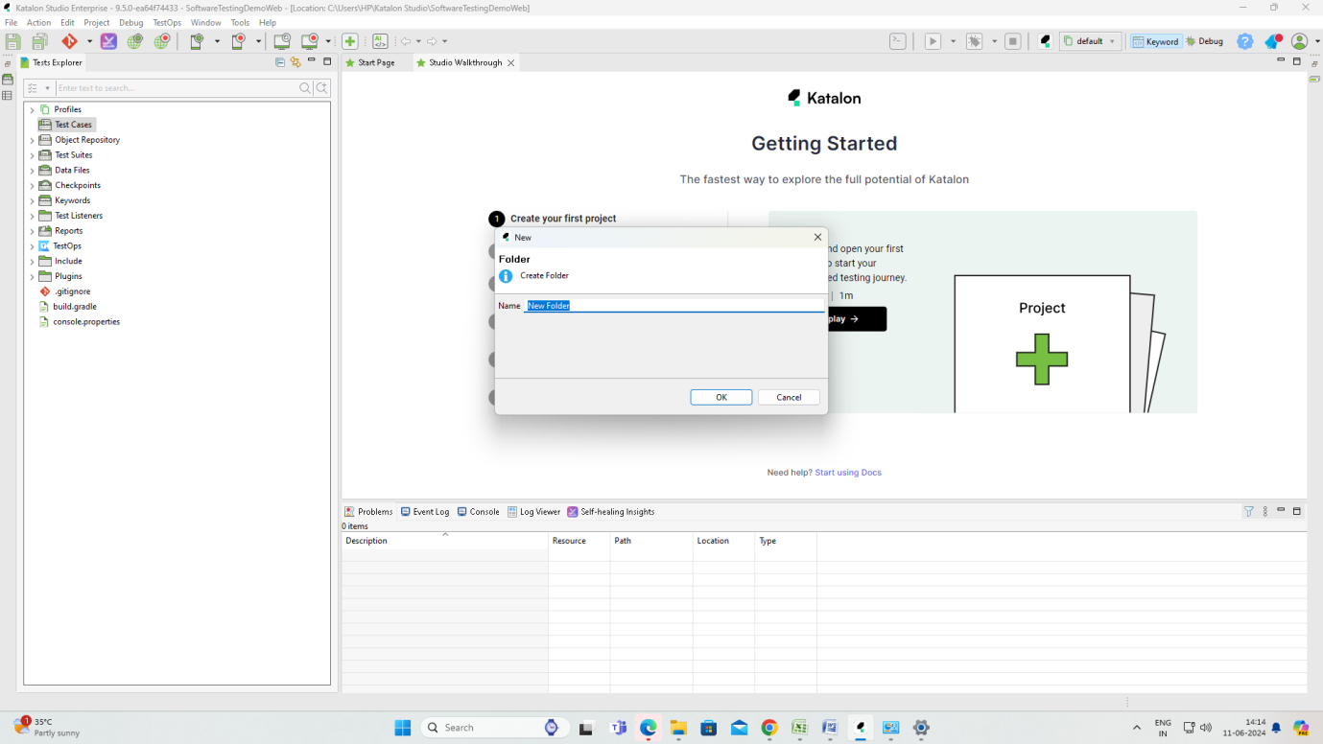

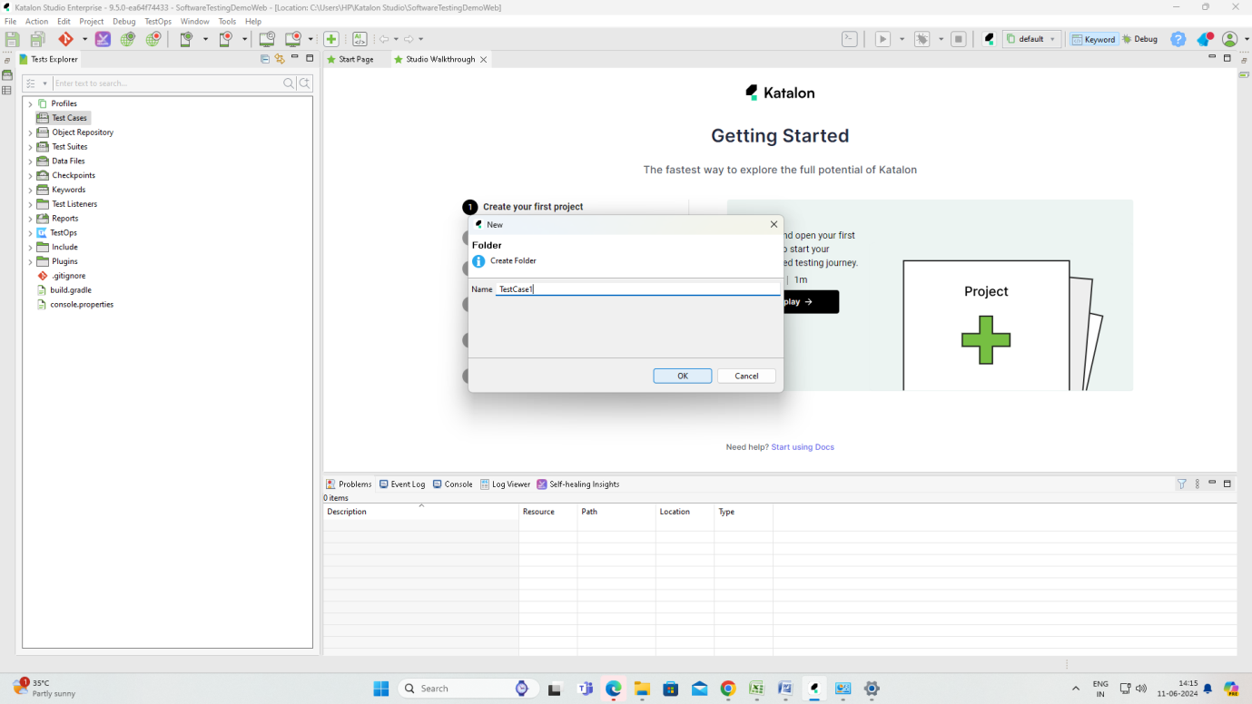

Record Web: Any URL Record. The web page will be opened. Click the pages. Stop Recording. Save Script

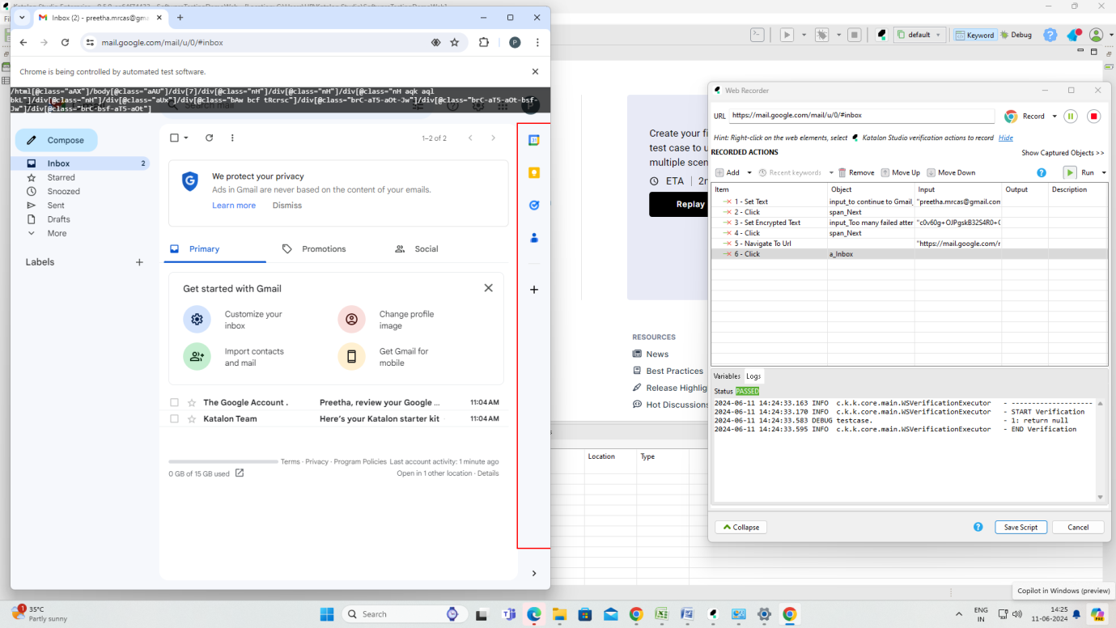

Press Save Script

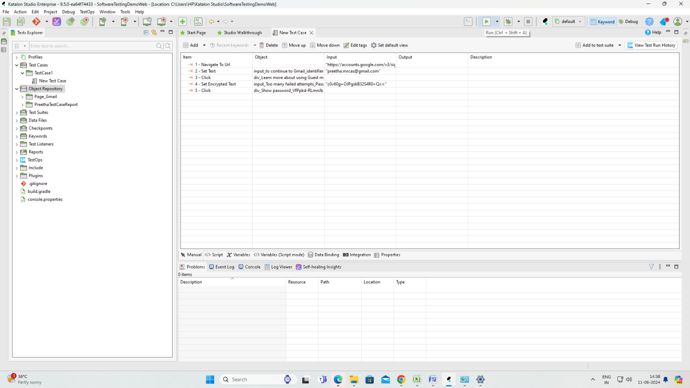

Press Run button

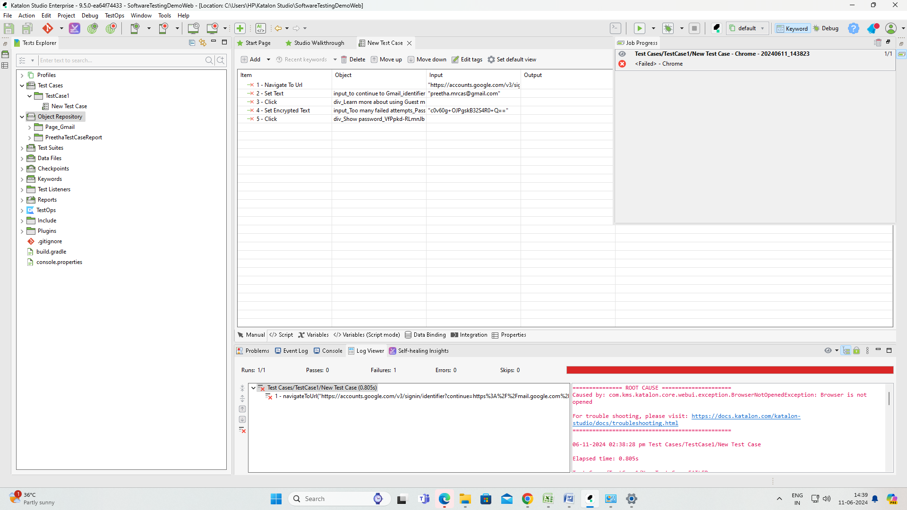

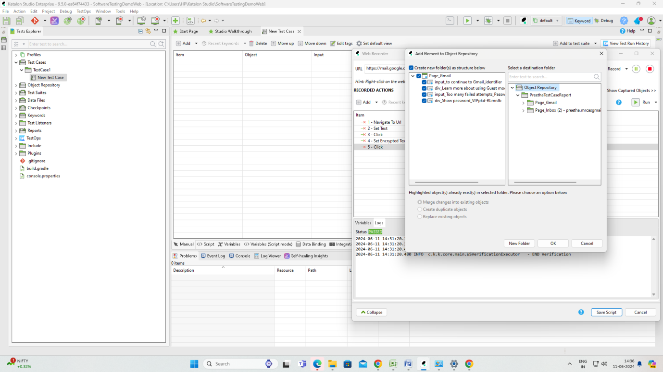

Pass, fail results will be shown

Once getting the results its our responsibility to send the analysis report to the developer by filling the excel sheet with possible fields like S. No, Page Link, Test Date, Test Time, P/F, Description

**12.06.2024(3rd Day)**

**Unit III – Test Case Creation and Management in Catalon Studio (10 Hrs)**

Git

Github – account login using your created gmail id. Password wont work

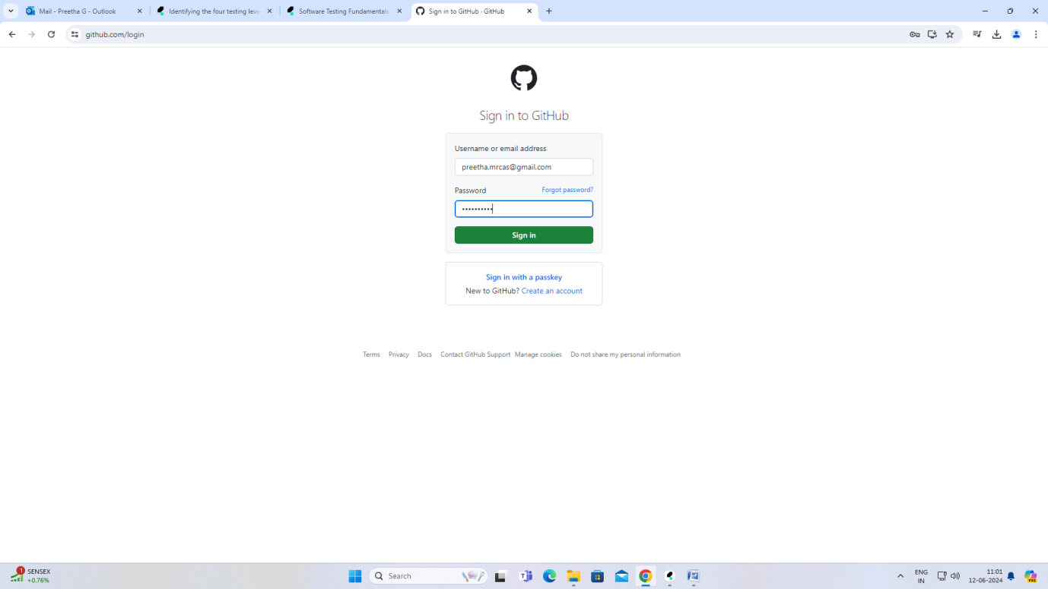

Create a new account for github

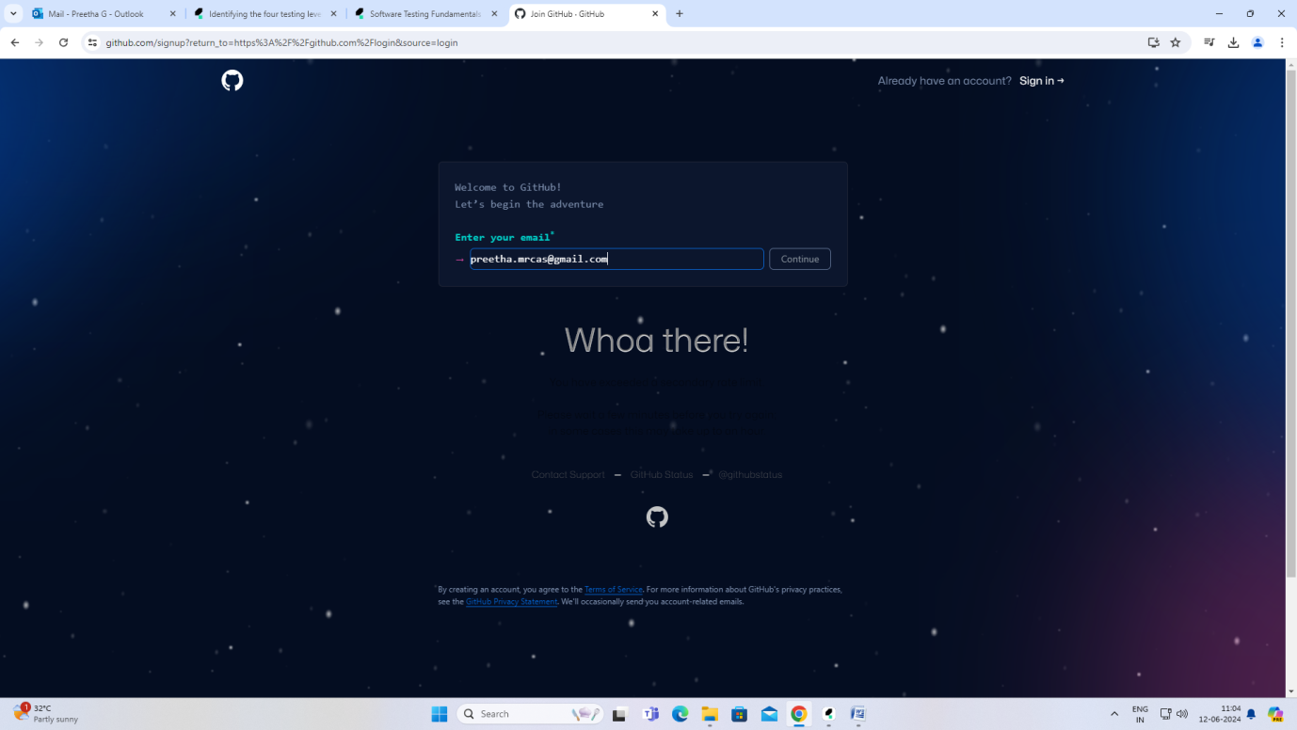

Github:

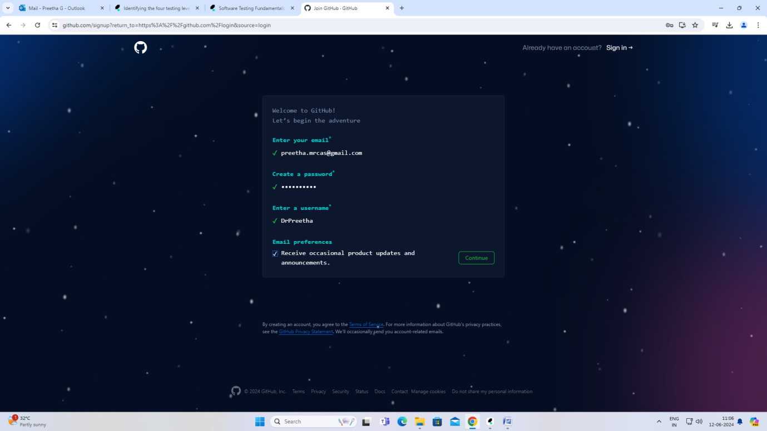

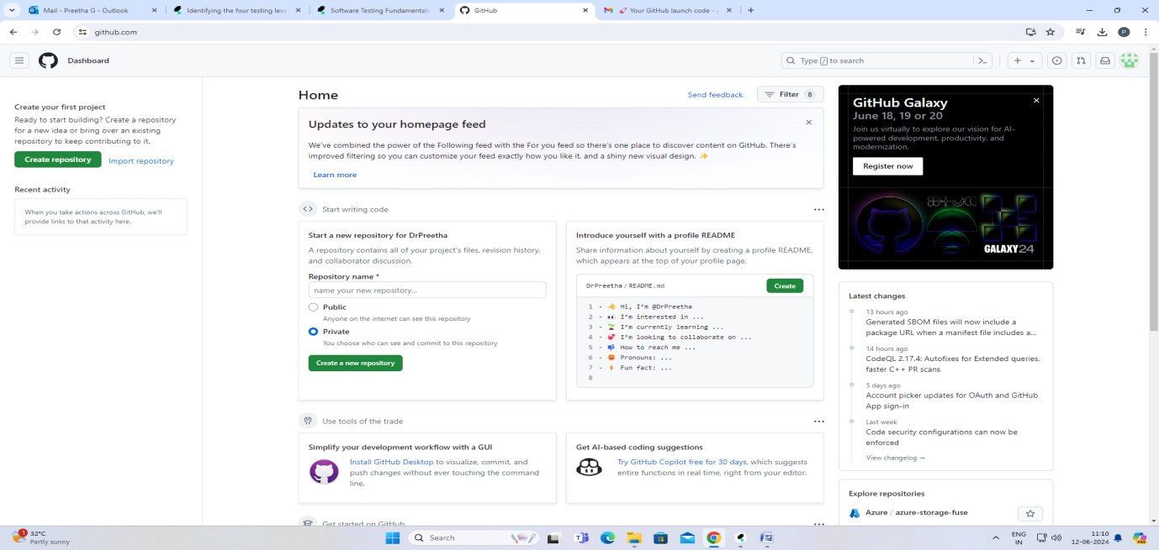Once this step gets over verification code will be sent to your mail. Enter that and you will redirect to Github username and password there u enter your github username and password.

3 projects need to create

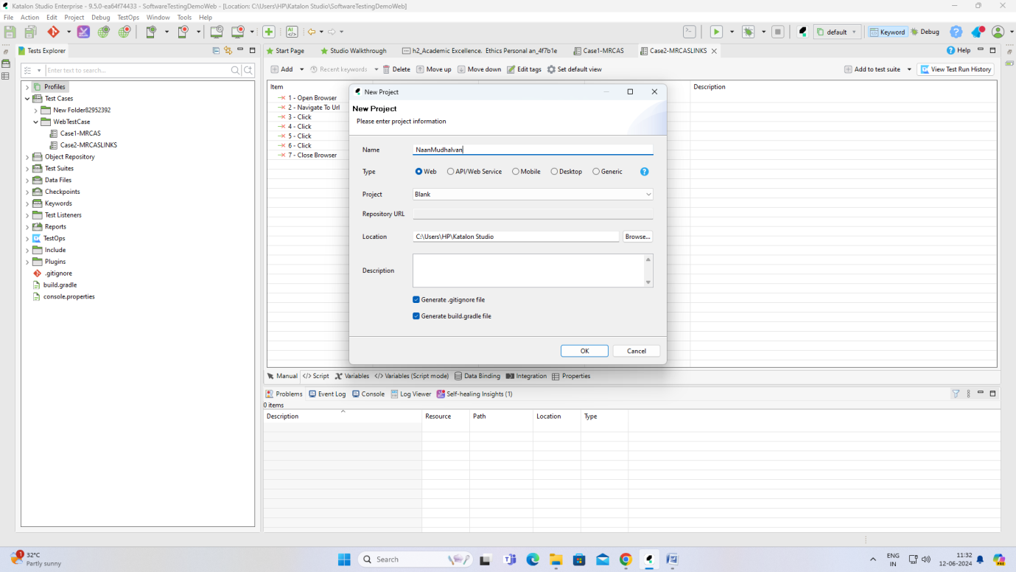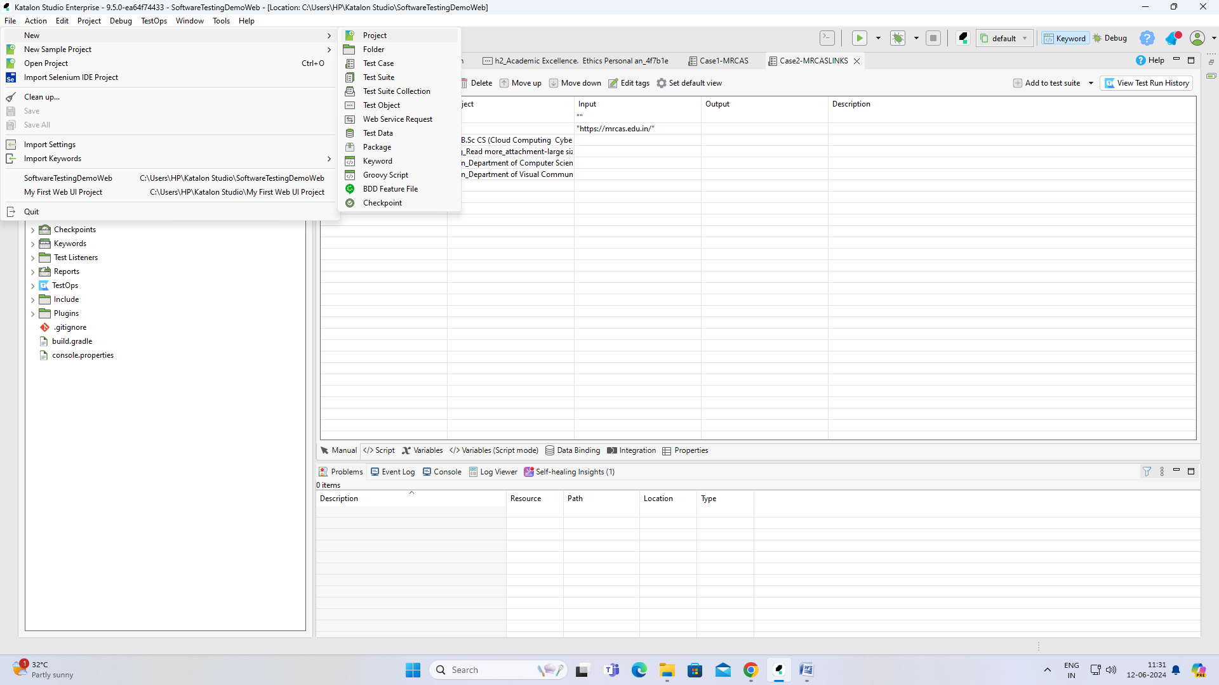

Once NaanMudhalvan new project is created. Next step is to create 3 new test cases

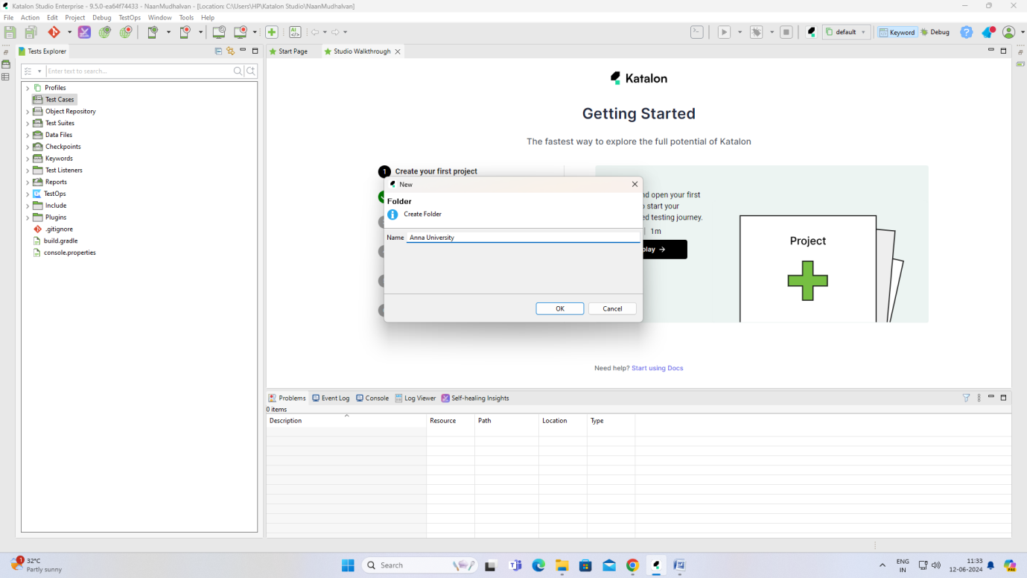

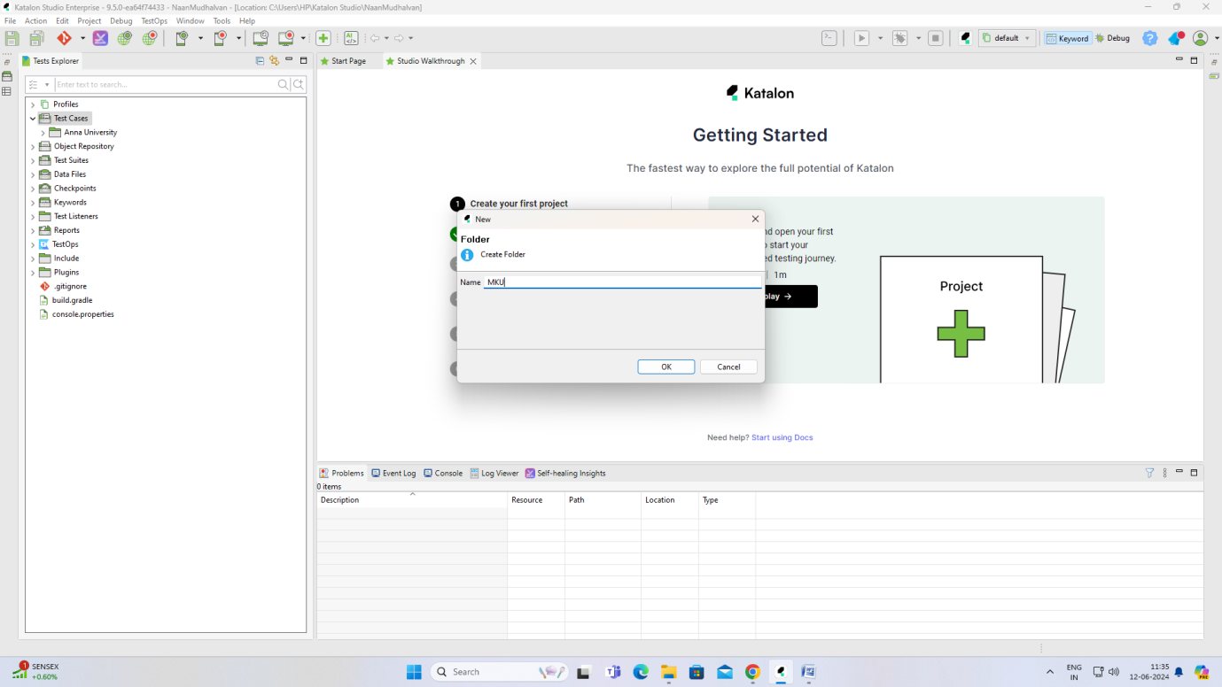

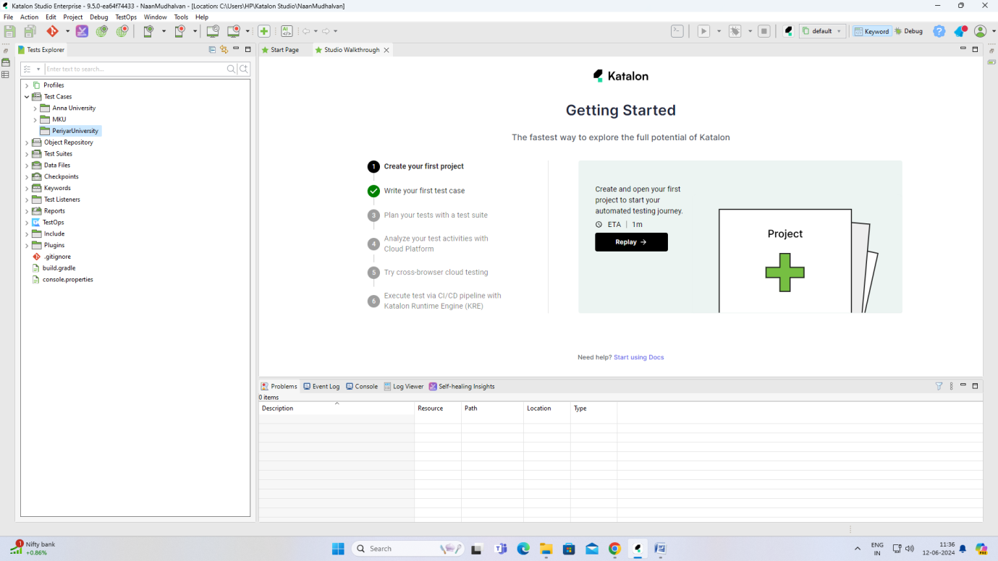

Steps to upload project in github

Create a new repository in github

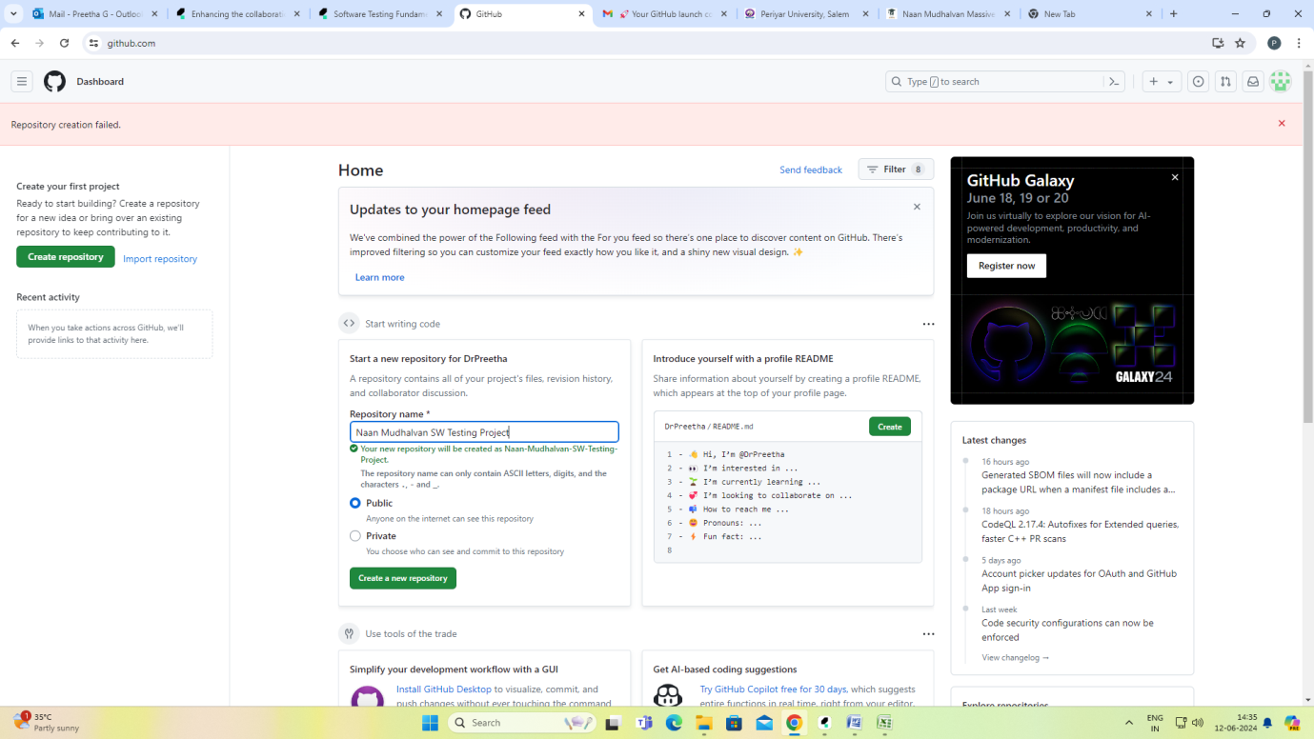

<https://github.com/DrPreetha/Naan-Mudhalvan-SW-Testing-Project.git>

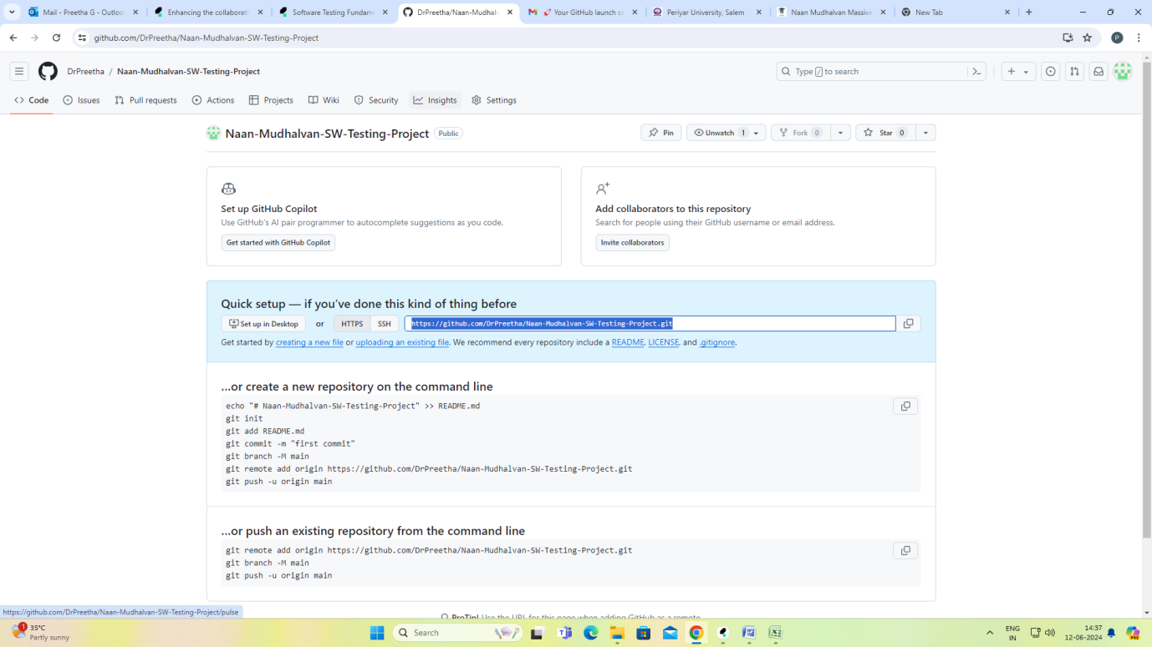

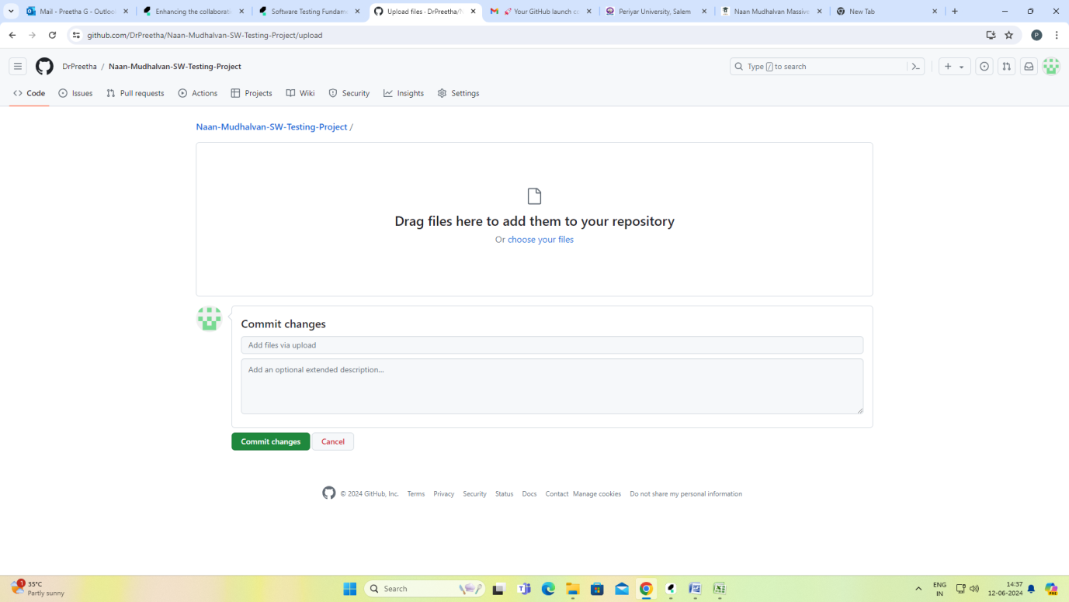

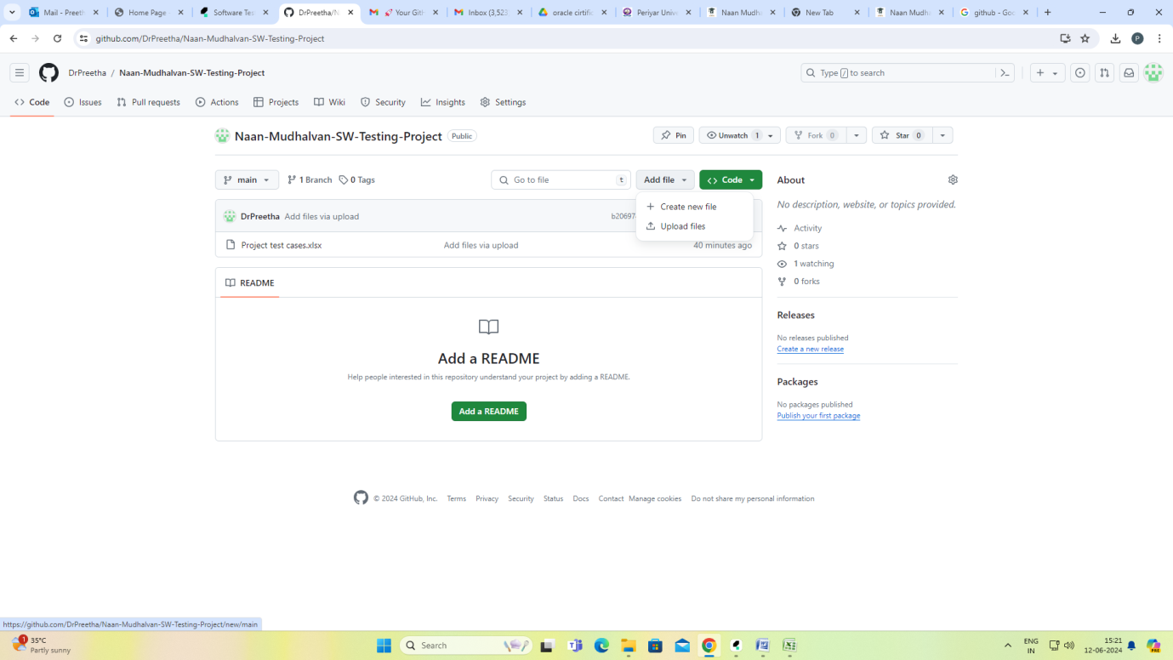

How to upload katalon project in Github

Once finished press commit changes

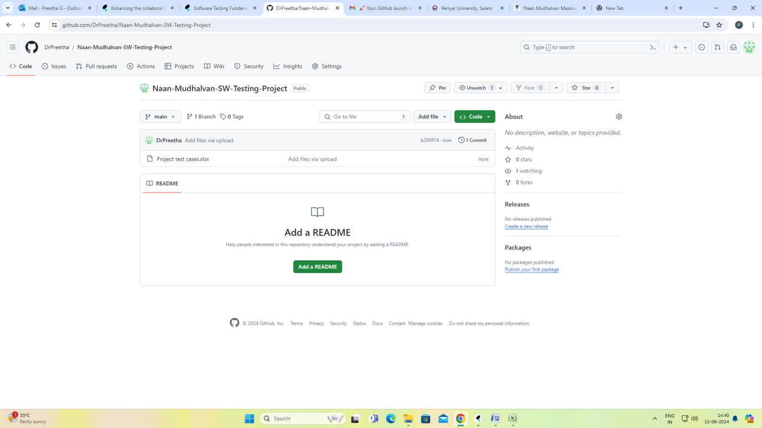

Git (Global Information Tracker) mainly for version control. So we can commit changes to our saved files n number of times. Based on date and commit no we can extract the latest files.

There are 3 options

Commit, Push, Pull

Create new batch for uploading and sharing docs with our team members

Upload project in github

